**CREATIVE COMPUTING C.A1**

A picture containing text

Description automatically generatedN00145104 // Daniel Roberts

# Theoretical Basis

*“Tension is highest when order borders on chaos. Individual forms abandon their strict arrangement in the dynamic grid and submit to random configurations. Elements inclined to the grid and those averse to it fight for visual supremacy. It is the moment of transition that is important.”*

*Generative Design, Chapter P.2.1.2*

This concept is explored in *Generative design*, in the “*Movement in a Grid* ” chapter and the results they managed to achieve were simple and effective. The idea of breaking down the structured order of a grid and visualising the transition to a chaotic, distorted system was intriguing and I decided to explore how artists have represented this idea in the past.

In researching this area I discovered the work of Georg Nees. Nees was a German academic and pioneer in the area of computer art and generative graphics, who used lithographs to create his pieces based on computer algorithms he wrote. His piece “Schotter” or “Gravel” created in 1970, beautifully illustrates a transition from order to chaos. I found the way in which Nees used computer graphics to illustrate such an ancient concept using such a simple composition, very intriguing. I decided to use Nees’ work as a baseline for exploring this idea and seeing in what way I could further elaborate on the concept.

A picture containing text


A picture containing text, map


Figure 2 "Schotter" Original piece, using a lithograph

Figure 1 "Schotter" recreated using p5.js

By examining Nees’ work I identified some of the factors at play in the composition of the piece. Nees uses exponentially increasing offset and rotation of the squares(modules) to create the chaotic effect. To further explore this idea of exponential increase of a factor, I decided to explore fragmentation, size, complexity of the modules and the modules connection to its point of origin.

To incorporate colour into the piece I wanted to explore how a transition from order to chaos can be interpreted through colour using interpolation, interpolation within modules and colour pallets generated according to colour theory principles. I explored each of these factors individually during early steps of the iterative process before experimenting with a combination of factors in the later stages.

# Main Steps in the Iterative Process

Of the 21 different iterations some bore better results than others. Below I have composed a list of the main stages of the iterative process that contributed most to the creation of the end piece.

### Mark 1 – Creating the Grid

The first step was creating an undistorted grid, this grid would be the basis of experimentation using the different factors as the piece progressed.

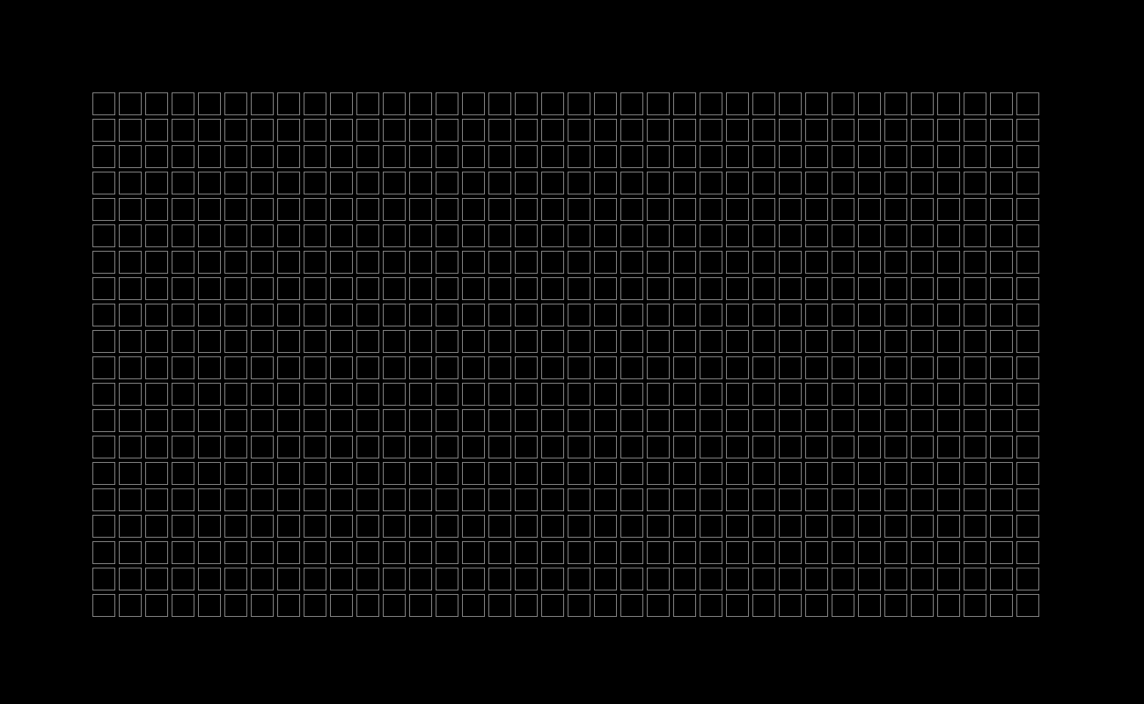

### Mark 2 – Rotation of Grid Modules

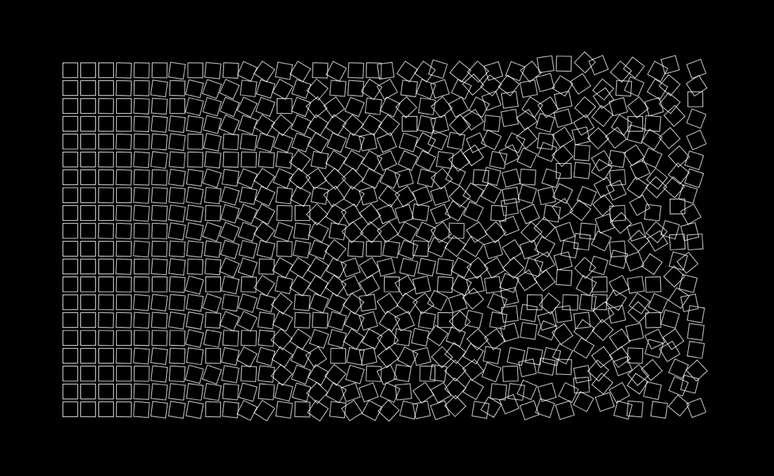To begin the process I started by implementing the factors employed by Nees in the original piece, beginning with rotation.

### 

### Mark 4 – Movement and Offset

In this mark, movement and module offset was implemented in addition to rotation, giving results similar to Nees’ original piece.

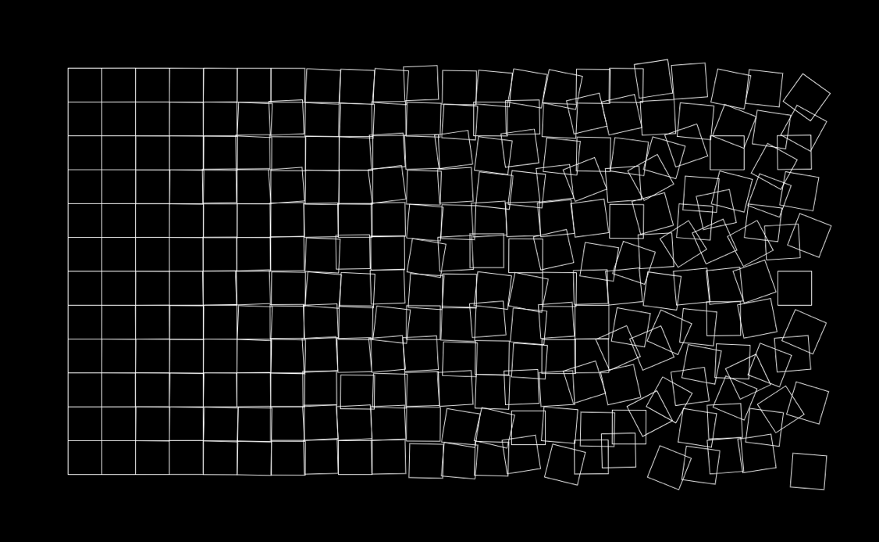

### Mark 7 - Fragmentation

In this mark I implemented module fragmentation. A fragmentation threshold was set and once a module’s offsetSum variable breaks this threshold, it will fragment into 4 smaller modules each being offset independently.

A close up of a mans face


### Mark 8 – Linear Interpolation Across the Grid

In this mark, the use of colour was explored as a means to visualise the transition from Order to chaos. This was done by colouring the ordered side of the grid with a deep grey, which interpolates the colour into a pallet of bright contrasting colours. The fragmentation and offset factors complemented this factor well.

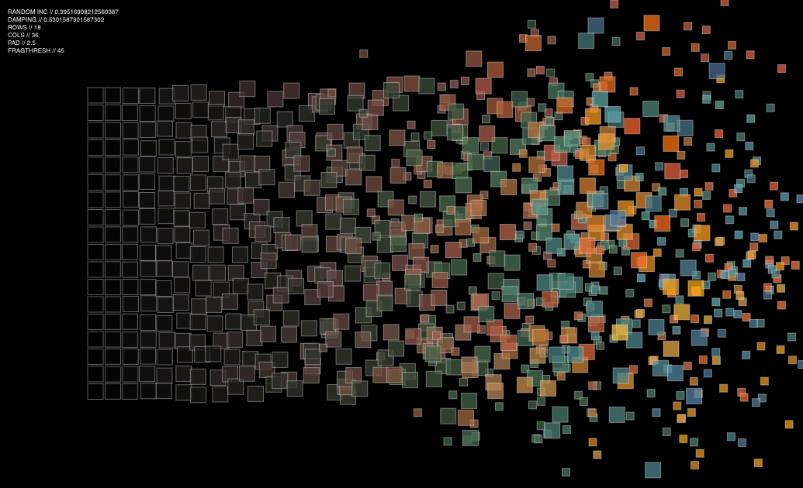

### Mark 11 – Size and Pseudo 3D

In this mark,the size of a module was mapped to the amount that is has been offset from it’s origin. By taking the absolute value (the magnitude of a number, which is always positive) of the combined X and Y offset, and mapping it to the renderSize variable, A pseudo 3D effect was achieved. This gave the modules with the most offset the largest size and the illusion of jumping out from the grid. Using rectangles resulted in too much overlap but better results were achieved later using circular modules.

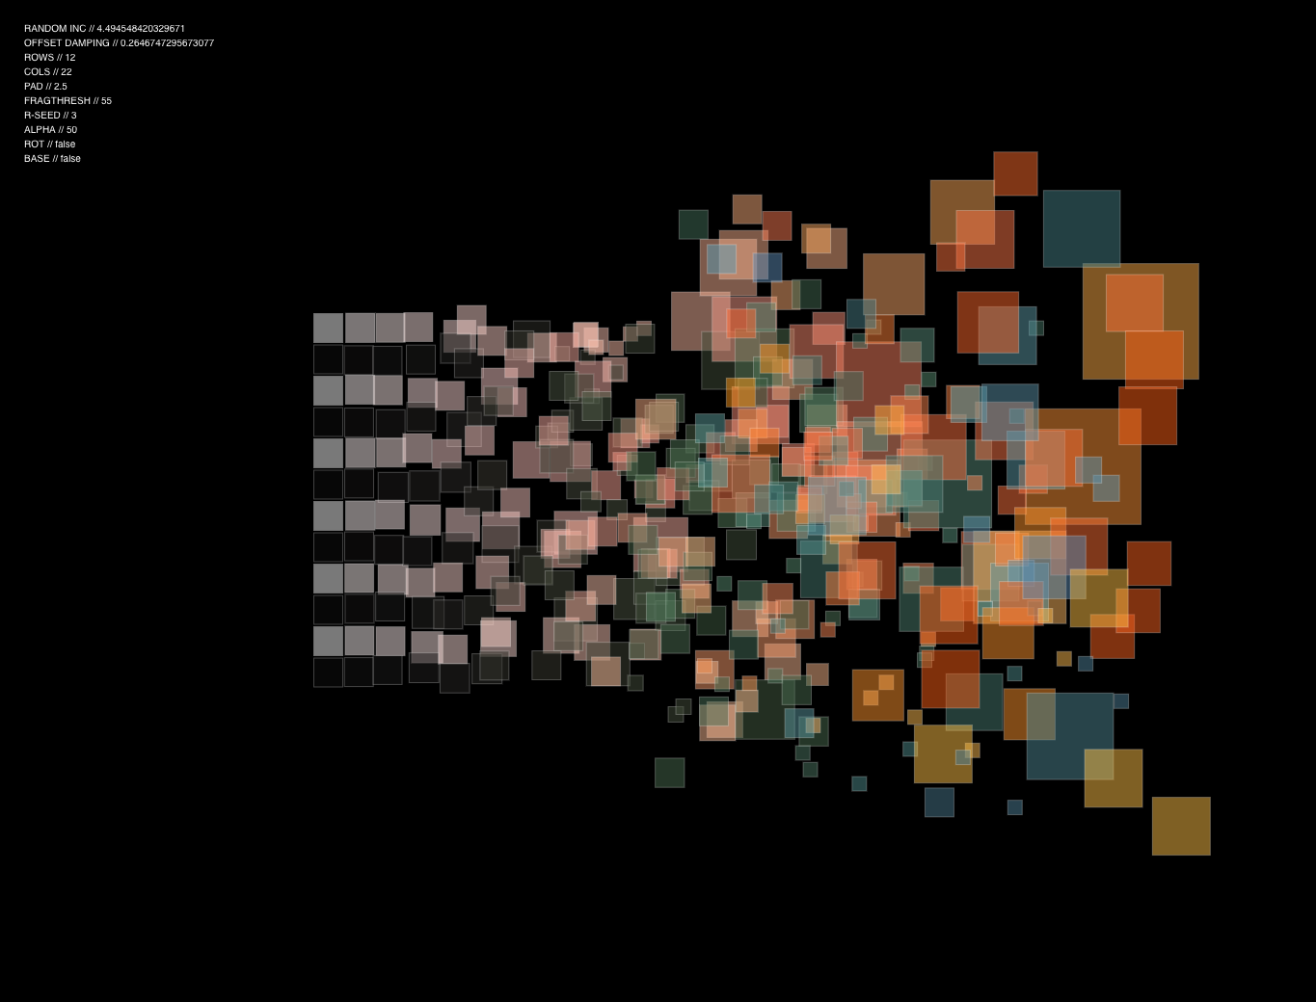

### Mark 13 – Complex Modules

In this mark, complex modules were implemented in place of simple ones like squares or rectangles. These complex modules are rendered using loops that create a system of concentric circles within a module. In subsequent marks the number of circle rendered in each module was assigned via interpolation from a minimum amount to a maximum amount across the grid. This too gave some interesting results. The added complexity of the modules combined with the Pseudo 3D produced pleasing results.

A close up of a logo

Description automatically generatedA close up of a device


### Mark 16 – Colour Interpolation Within Modules

A picture containing invertebrate

Description automatically generatedIn this mark, interpolation of colour was added to the concentric circles of each module. The modules outer circle would be coloured as the colour assigned by the first colour interpolation across the grid. As the module is rendered, a second colour was then defined for interpolation. The colour of the first interpolation would then lerp to this defined colour, moving closer to the value of the defined colour as each concentric circle was rendered in the module.

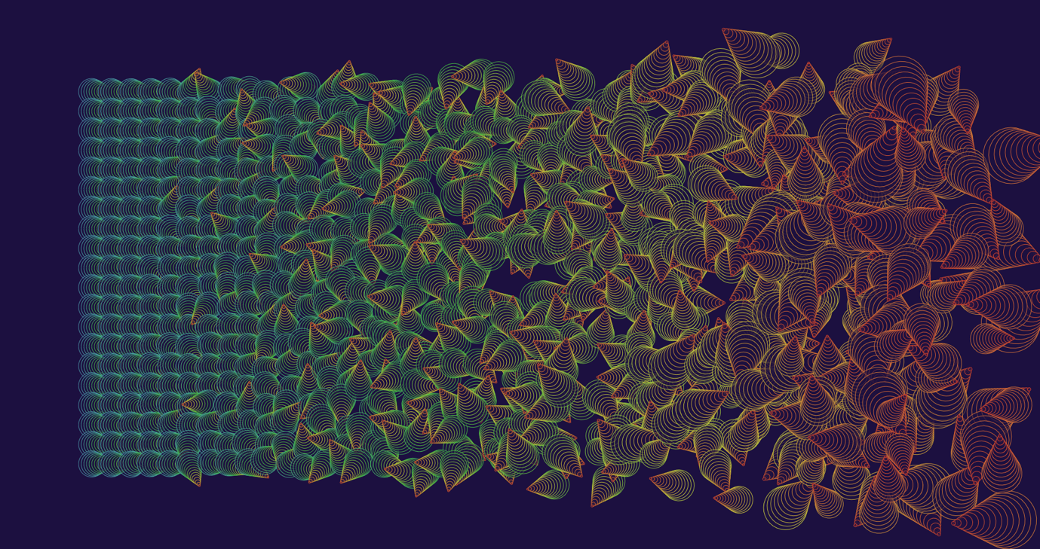

### Mark 17 – Finished Piece

The culmination of this exploration resulted in following piece. The piece was generated entirely using p5.js and was only edited for sizing. Should the piece require placement of a title, there is space set aside at the bottom, between the white border and the edge.

The factors that compose the finished piece are:

* Module offset based on incremental accumulation from bottom to top.
* Module rotation with range based on offset.
* Complex Modules composed of multiple simple shapes.
* Colour Interpolation from bottom to top.
* A colour array for the bottom, populated using off black and off white to give an ordered sense of composition.
* A colour array for the top, populated using a tertiary colour palette to maintain the visual aesthetic amongst the chaotic composition.
* A white border to give a sense of the chaotic modules breaking through a boundary which restrains the ordered modules.

